PF Lab assignment #8

Mohammad Yehya , K213309

Table of Contents

**Question #1** 2

**Question #2** 3

**Question #3** 4

**Question #4** 5

**Question #5** 7

**Question #6** 8

**Question #7** 9

**Question #8** 10

**Question #9** 13

# **Question #1**

#include <stdio.h>

int main()

{

int n,i,a[10],count=0;

for (i = 1 ; i <= 10 ; i++)

{

printf("Please enter a number to store in the array at position No.%d: ",i);

scanf("%d",&a[i]);

}

printf("Please enter a number to search in the array: ");

scanf("%d",&n);

for (i = 1 ; i <= 10 ; i++)

{

if (a[i]==n)

{

count++;

}

}

if (count == 0)

{

printf("Number not found!");

}

else

{

printf("The number %d has occured %d times.",n,count);

}

}

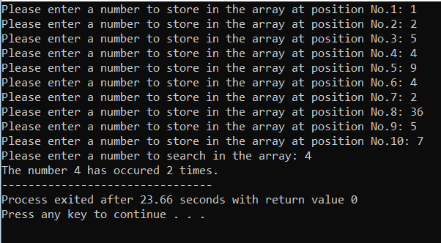

# **Question #2**

#include <stdio.h>

int main()

{

int i;

float arr[6];

for (i = 1 ; i <= 5 ; i++)

{

printf("Please enter a number: ");

scanf("%f",&arr[i]);

}

for (i = 5 ; i >= 1 ; i--)

{

printf("%0.2f\n",arr[i]);

}

}

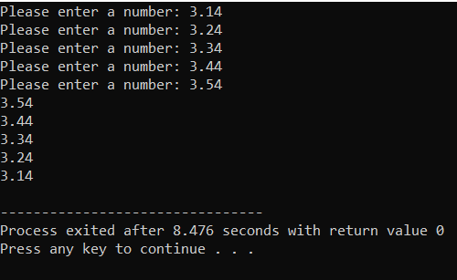

# **Question #3**

#include <stdio.h>

int main()

{

int posisum=0,negsum=0,n[6],i;

for (i = 1 ; i<= 6 ; i++)

{

printf("Please enter a number: ");

scanf("%d",&n[i]);

if (n[i] > 0)

{

posisum = posisum + n[i];

}

else if (n[i] < 0)

{

negsum = negsum + n[i];

}

}

printf("The sum of all postive numbers is: %d\n",posisum);

printf("The sum of all negative numbers is: %d\n",negsum);

printf("The sum of all numbers is: %d",posisum+negsum);

}

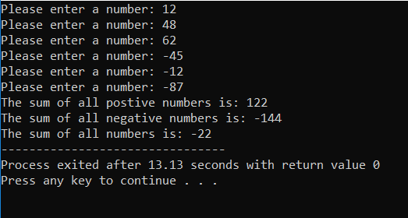

# **Question #4**

#include <stdio.h>

int main()

{

int marks[10],i,fail[10]={0},pass[10]={0},failcount=0,passcount=0,avgfail=0,avgpass=0;

for (i = 1 ; i <= 10 ; i++)

{

printf("Enter the marks of student %d: ",i);

scanf("%d",&marks[i]);

if (marks[i] == -1)

{

break;

}

if (marks[i] > 0 && marks[i] < 5)

{

fail[i] = marks[i];

failcount++;

}

else if (marks[i] < 10 && marks[i] > 5)

{

pass[i] = marks[i];

passcount++;

}

}

for (i = 1 ; i <= 10 ; i++)

{

avgfail += fail[i];

avgpass += pass[i];

printf("The marks of student %d is: %d\n",i,marks[i]);

}

printf("The average of the fail students is: %d\n",avgfail/failcount);

printf("The average of the pass students is : %d",avgpass/passcount);

}

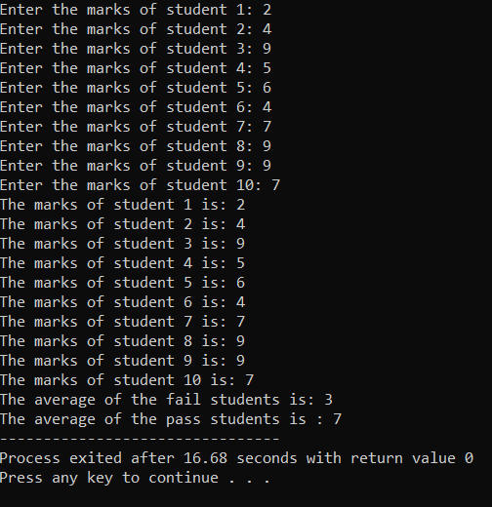

# **Question #5**

#include <stdio.h>

int main()

{

int arr[10],pos=0,neg=0,zero=0;

for (int i = 1 ; i <= 10 ; i++)

{

printf("Please enter a number %d: ",i);

scanf("%d",&arr[i]);

if (arr[i] > 0)

{

pos++;

}

else if (arr[i] < 0)

{

neg++;

}

else zero++;

}

printf("The number of positive numbers is: %d\n",pos);

printf("The number of negative numbers is: %d\n",neg);

printf("The number of zeros is: %d",zero);

}

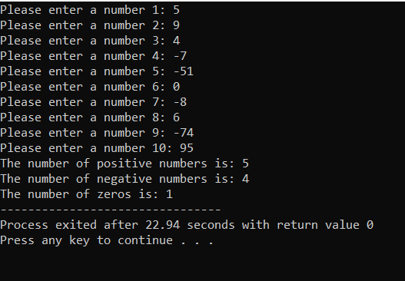

# **Question #6**

#include <stdio.h>

int main()

{

int num,digits[9999],sum=0;

do

{

printf("Please enter a number that has 4 or more digits: ");

scanf("%d",&num);

}

while(num < 1000);

while (num > 0)

{

sum = sum + num%10;

num = num/10;

}

printf("The sum of the individual digits is: %d",sum);

}

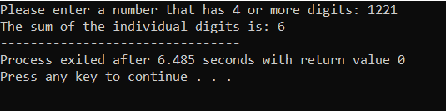

# **Question #7**

#include <stdio.h>

int main()

{

int n,even=0,odd=0,sum=0;

printf("Enter array size[1-100]: ");

scanf("%d",&n);

int arr[n];

for (int i = 1 ; i <= n ; i++)

{

printf("Enter element %d: ",i);

scanf("%d",&arr[i]);

sum = sum + arr[i];

if (arr[i]%2==0)

{

even++;

}

else odd++;

}

printf("Total Sum: %d\n",sum);

printf("Even numbers: %d\n",even);

printf("Odd numbers: %d\n",odd);

}

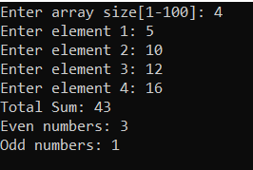

# **Question #8**

#include <stdio.h>

int main()

{

int a,b,c;

for (a = -10 ; a <= 10 ; a++)

{

for (b = -10 ; b <= 10 ; b++)

{

for (c = -10 ; c <= 10 ; c++)

{

if (3*a+7*b-5*c == 10)

{

printf("Solution: %d %d %d\n",a,b,c);

}

}

}

}

}

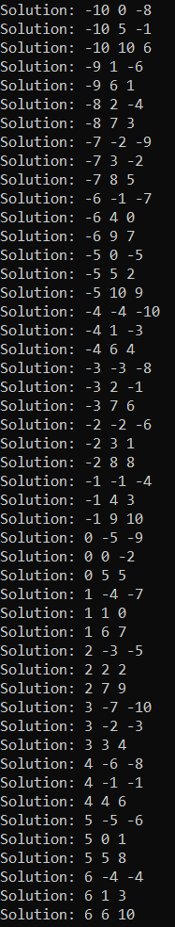

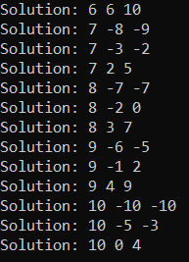

# **Question #9**

#include <stdio.h>

int main()

{

int n,i,j,k = 1;

printf("Enter number of rows: ");

scanf("%d",&n);

for (i = 1 ; i <= n ; i++)

{

for (j = 1 ; j <= i ; j++)

{

printf("%d ",k++);

}

printf("\n");

}

printf("Enter number of rows: ");

scanf("%d",&n);

for (i = 1 ; i <= n ; i++)

{

for (j = 1 ; j <= i ; j++)

{

printf("* ");

}

printf("\n");

}

printf("Enter number of rows: ");

scanf("%d",&n);

for (i = 1 ; i <= n ; i++)

{

for (j = 1 ; j <= n ; j++)

{

printf("%d ",i);

}

printf("\n");

}

}

